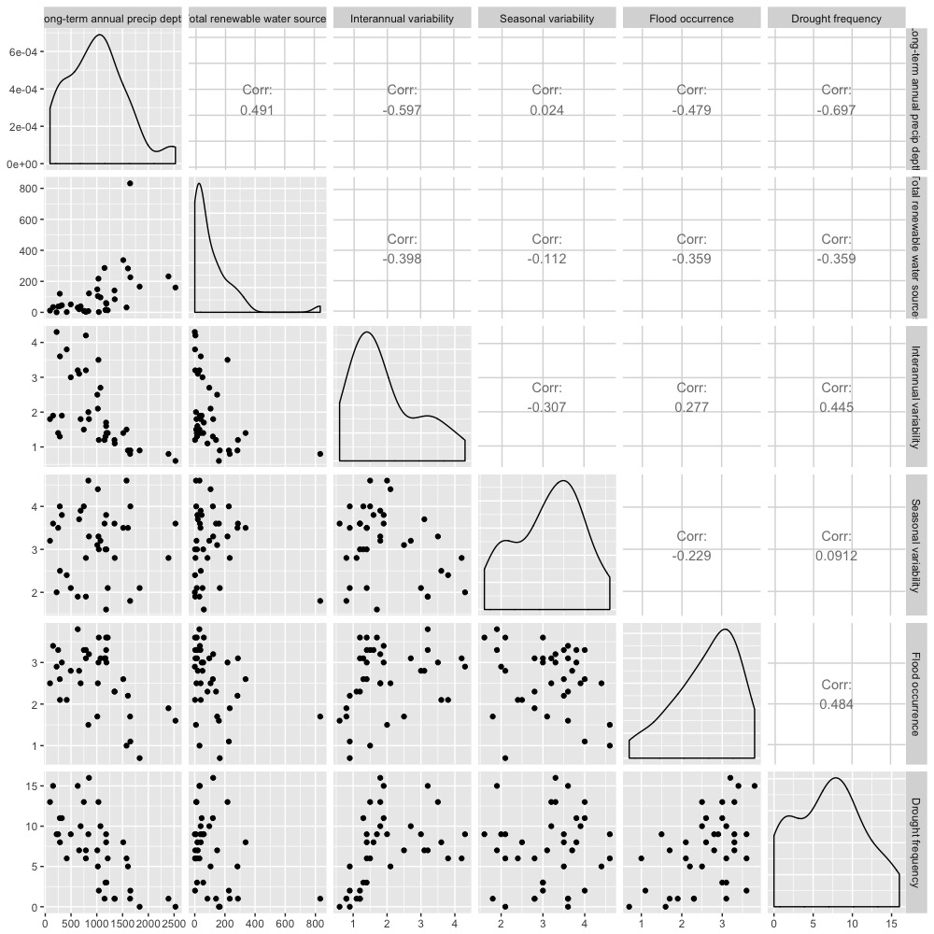

We can see the water resources availability, variability, and extreme weather events are highly correlated.

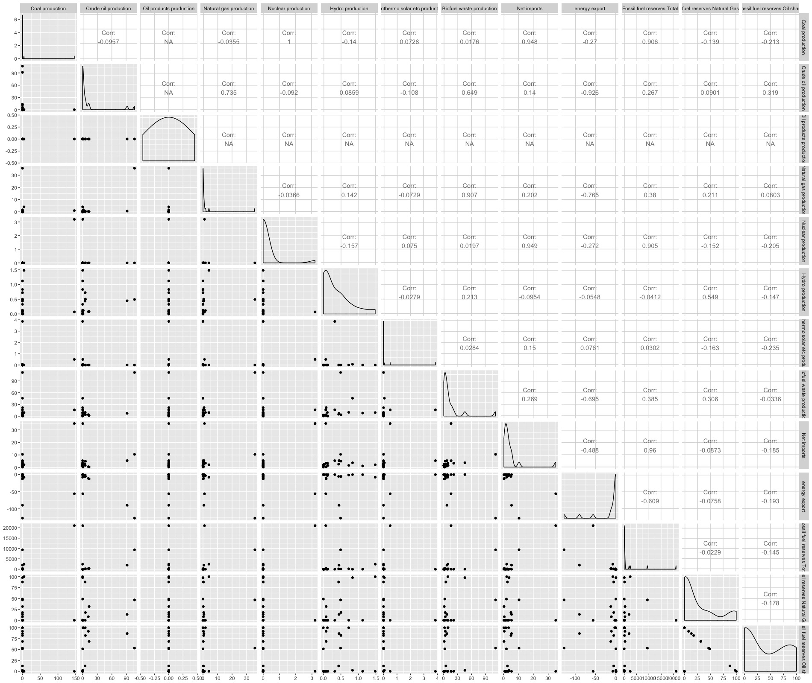

We can see from this correlation matrix of the independent variables of energy resources, many countries have numbers of zero, so we see NA values. The distribution of the energy data are so skewed.

T suggestion Week of Jan 22 to 26:

1. For energy, given that a lot of the data is wonky/related, it might be worth it to explore a hierarchical/multi-level regression. Where basically, y ~ total production + net imports + energy exports + total reserves, where total production and fuel reserves are composed of the different fuel types we have data for.

Since Oil Products that no countries have any, we can eliminate that data in the stepwise regression.

* Total fossil vs total non-fossil (Week of Jan 29 – Feb 2 Updates)

\*The fossil fuel domestic production includes coal, crude oil, oil products (aviation gas, bitumen, ethane, fuel oil, gas/diesel, Kerosene, jet fuel, LPG liquefied petroleum gas, lubricants, motor gasoline, naphtha, and other oil products (tar, Sulphur, and grease), and Natural Gas.

\*Assumption: all net imports are balance after consider export. All net imports are types of fossil fuel.

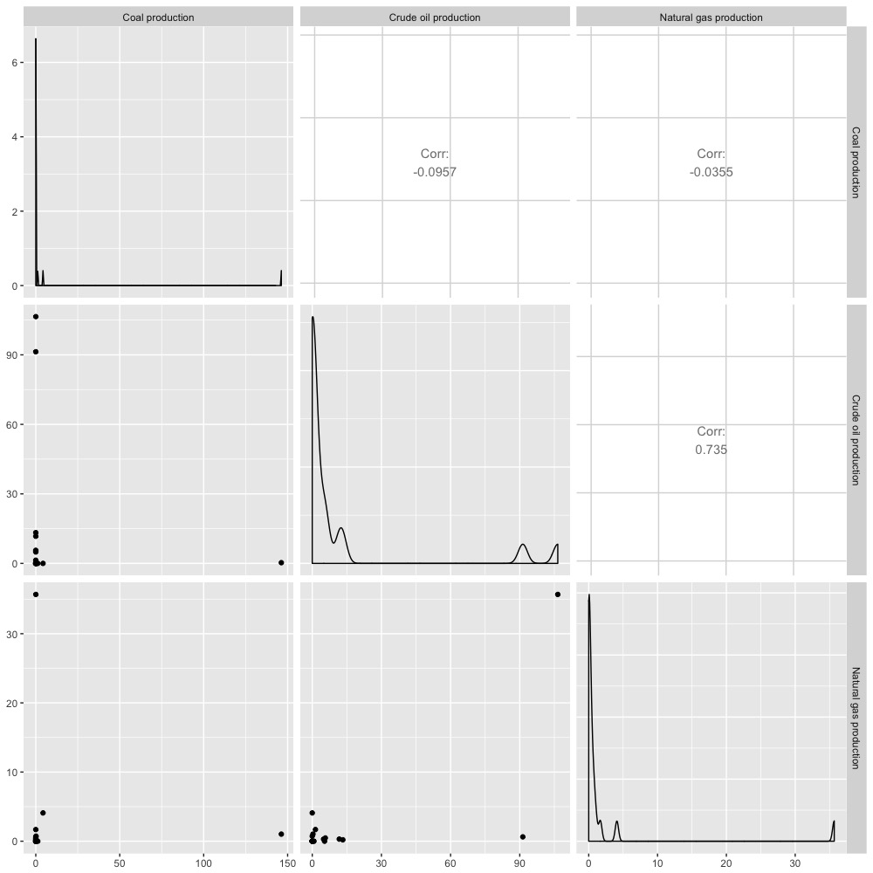

Crude oil is highly correlated to Natural gas (0.735). It seems like coal is relatively irrelevant to other two fossil fuel resources. (Oil products production is eliminated due to all zero values) Since the rest of the dataset contains zero, log transform cannot be performed as well. (one way is to set all zero value to a small positive value and proceed to log transform, we could discuss the feasibility)

\*Non-fossil fuel domestic production includes nuclear, hydro, geothermal solar and other, and Biofuel and waste production.

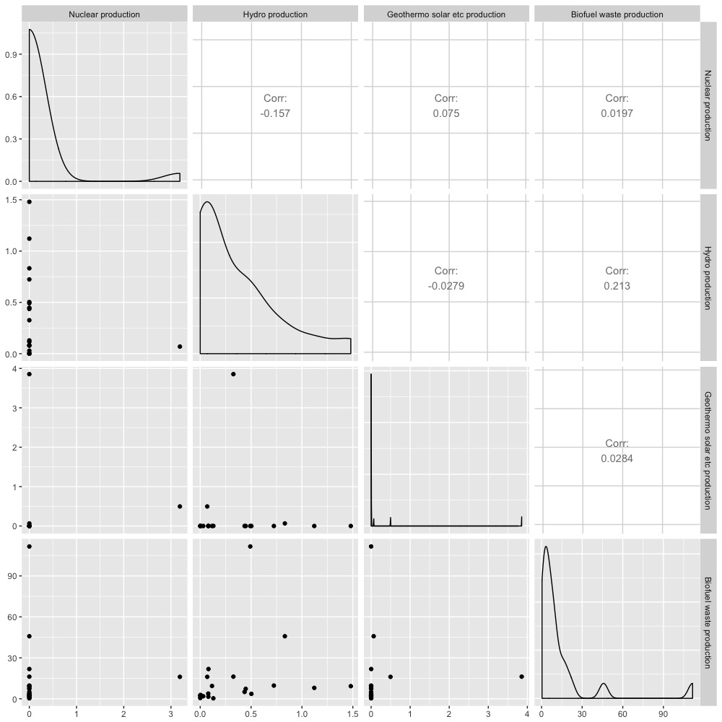

* In biofuel session, charcoal was used but not reported “In most countries, only the primary solid biofuels are reported.” Other forms of biofuel and waste can be considered as sustainable non-fossil fuel.
* Fossil fuel production vs non fossil fuel production: 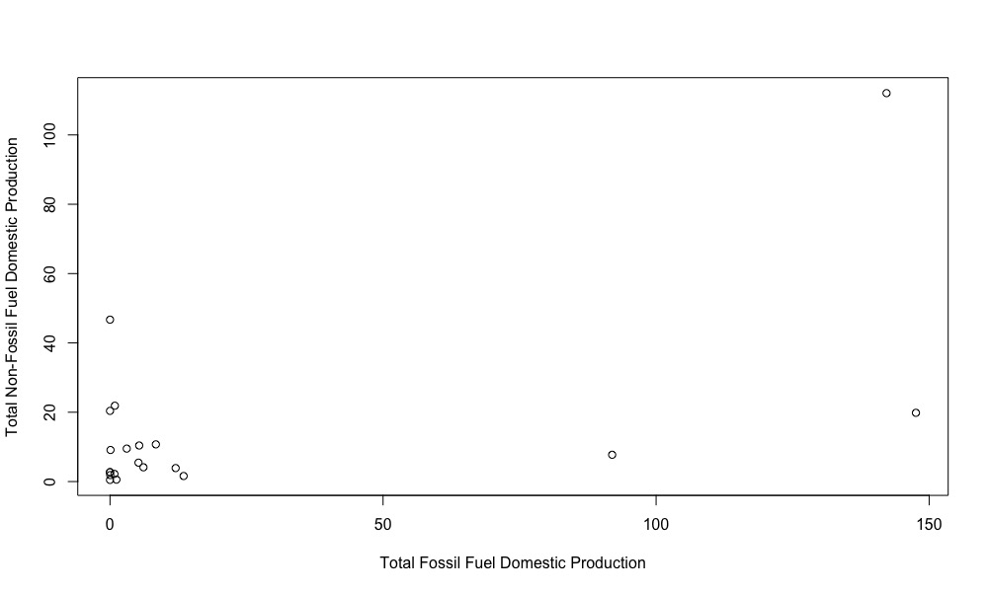

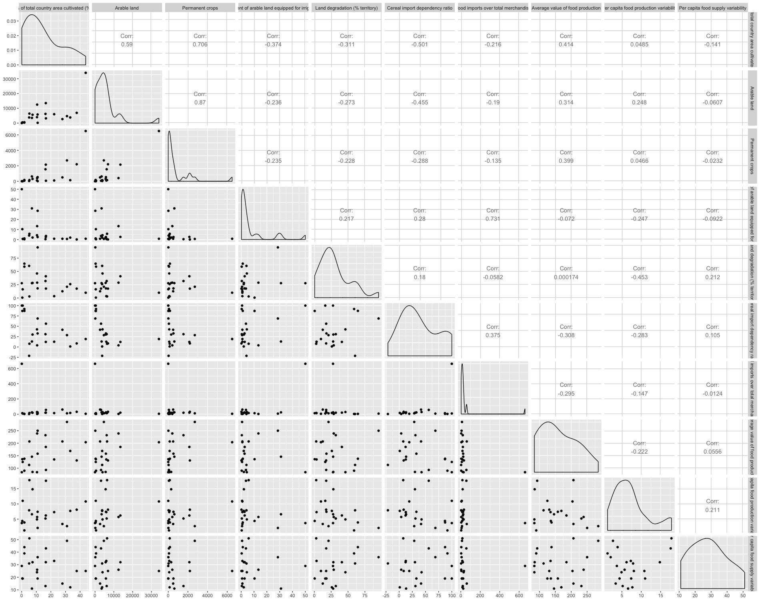

This is the correlation matrix of the food (land resources) independent variables. The land resource availability variables (total area cultivated, permanent crops, arable land, percentage of irrigation, land degradation). Rail line density (not in this graph) are highly correlated with most of the variables, which food import and percentage of irrigation land are the most correlated variables.

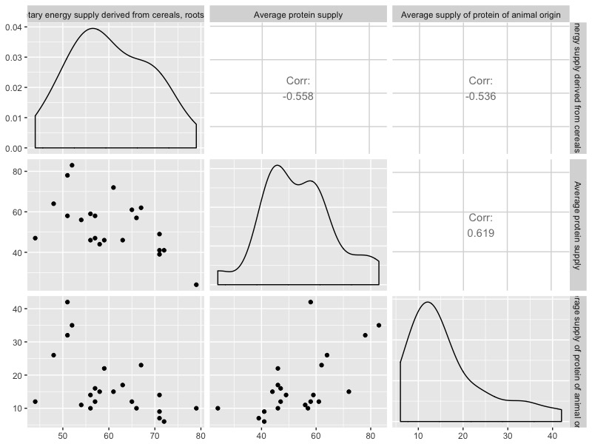

Share of dietary energy supply derived from cereals roots and tubers, average protein supply, average supply can be interpreted as measures of utilization: nutritional balance.

We can see that the three are also very highly correlated.

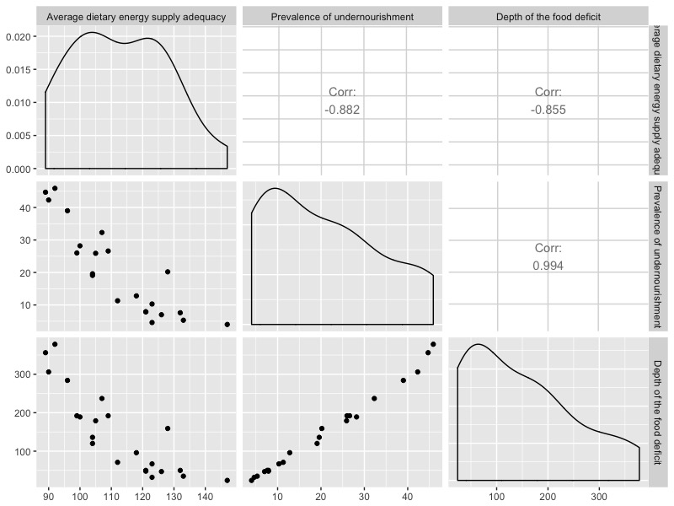

Average dietary energy supply adequacy, prevalence of undernourishment, and food deficit can be all interpreted as measures of general utilization of food. The three variables are highly correlated. Food deficit are rather significantly correlated to prevalence of undernourishment.

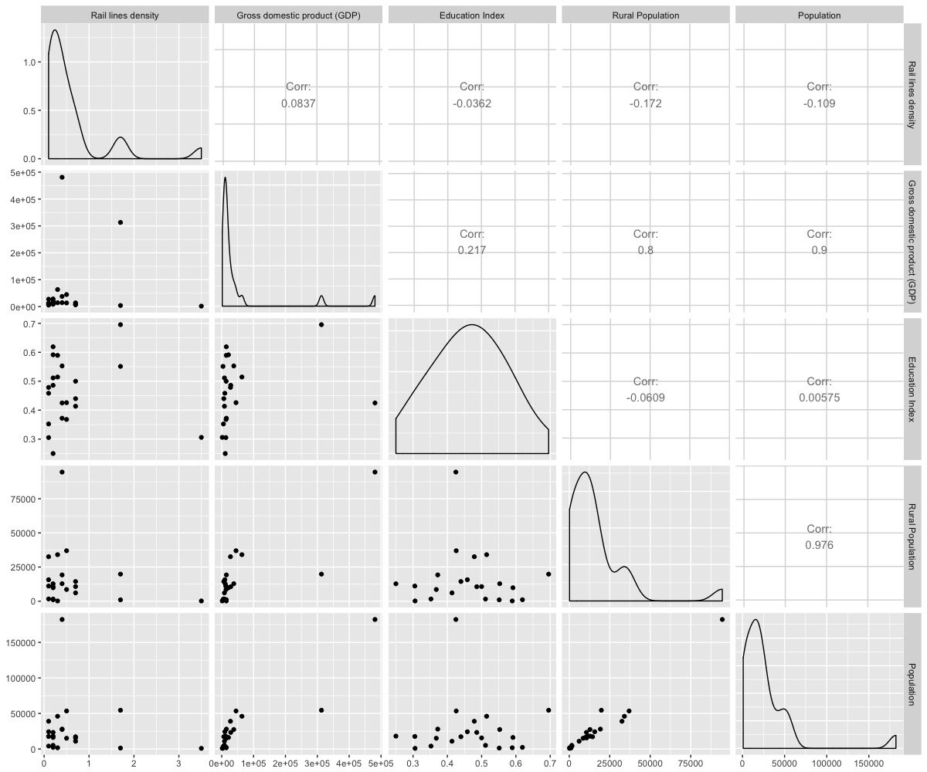

(Week of Jan 29 to Feb2 update)

This is the correlation matrix for human intervention/capacity variables in the food dataset. The high correlations between populations and GDP are obvious, but we see a negative correlation coefficient between rural population and rail lines density (-0.2).

T comment week (Jan 22 to Jan 26)

2. For food, I like how you broke out some of the variables into related groups (I.e., nutritional balance and deficit/lack of availability). These findings are interesting in and on themselves (e.g., prevalence of undernourishment vs depth of food deficit almost look like they were derived from each other! Is this next step to do a PCA on these mini groups?

Jack Addressing Notes:

* The plan is to do pca on the first group of the land resources availability. And the second is to perform the pca for the nutritional balance, the third plan is to choose the deficit of food.
* Capacity variables, include the correlation variables from the outcomes.
* Pull irrigation, pull that out as a capacity variable.

Second word document, Clean Version, include PCA, more into text.

Last document will be the regression.

Once we have all the final variables, make copy of the framework and put the variables into the diagrams. Track Units, and Year.

Table for the variables (presented in Paper). A compact way to keep track of everything.